**Mo-Buzz Dengue**

Nanyang Technological University (NTU), Colombo Municipal Council (CMC), Mobitel and University of Colombo School of Computing (UCSC)

Contents

1. DOCUMENT OVERVIEW 3

1.1. SCOPE 3

1.2. AUDIENCE 3

1.3. RELATED DOCUMENTATION 3

2. SYSTEM OVERVIEW 3

2.1. DESCRIPTION 3

2.2. SYSTEM ARCHITECTURE 4

3. SOFTWARE OVERVIEW 5

3.1 DESCRIPTION 5

3.2 SOFTWARE ARCHITECTURE 6

3.3 USER INTERFACES 11

3.3.1 Mo-Buzz Dengue 11

3.3.2 Mo-Buzz Dengue Management Console 14

3.3.3 CMC Public Health 16

4 DATABASE 18

5 RELATED SOFTWARE 20

5.1 DEPENDENCIES 20

6 DEPLOYMENT OF THE SYSTEM 20

7 APPENDIX 22

# DOCUMENT OVERVIEW

## SCOPE

This document includes the technical description for the project Mo-Buzz (Public System). The document can be referred as the starting document for and development, customization or improvement to the existing system from the perspective of software engineering.

The document includes the information regarding Mo-Buzz Public System which developed targeting general public in Colombo Municipal Council (CMC) jurisdiction and PHIs of CMC.

## AUDIENCE

Documentation is targeted for the people who are having knowledge in computer since or engineering. This document consists of general system analysis, design methods and required diagrams. Hence sections mainly focus software engineers, system administrators, database administrators, android developers or any equivalent positions.

## RELATED DOCUMENTATION

This documentation doesn’t require any supporting document.

# SYSTEM OVERVIEW

# DESCRIPTION

Mo-Buzz solution is consists with 3 main components (systems) namely: “Mo-Buzz Dengue” (Android application), “Mo-Buzz Dengue Management Console” (Web application) and “CMC Public Health” (Android application).

Mo-Buzz Public is an integrated mobile and desktop-based dengue communication system that is built upon PE principles. Mo- Buzz extends its reach to provide an interface between citizens and health authorities, and helps to enhance preventive behaviors and health awareness. As mention in the intervention, this system comprises three main components which are predictive surveillance, civic engagement and health communication which operates trough different applications to achieve intended results. This system is compromise of three applications which work together to complete the information flows in three components of the intervention. System equipped with two android applications called ‘Mo-Buzz Dengue’ (used by the general public) and ‘CMC Public Health’ (used by the public health offices), and web application called ‘Mo-Buzz Dengue Management Console’ (used by municipal council management). All these three applications work together with Mo-Buzz Public backend to complete the work flows of the system. Figure shows the overview of how all three applications are integrated to each other in the Mo-Buzz Public System.

With these applications you can do:

1. Mo-Buzz Dengue

Mo-Buzz Dengue is an android application which acts as the public-front-end of the system. With this app general public can report breeding sites, get latest dengue outbreaks as hotspots and dengue-educational materials.

1. Mo-Buzz Dengue Management Console

This management Console is the main administration-panel for the whole system. Through this application, responsible personals in CMC can manage all the data, public users and the public health inspectors (PHIs).

1. CMC Public Health

CMC public health is the android app used by PHIs to access public data and validate this information. PHIs are expected to tack necessary actions for valid information reported by general public and then update the status of the public report.

# SYSTEM ARCHITECTURE

General public in CMC jurisdiction can use the ‘Mo-Buzz Dengue’ app to make a complaint to the CMC. This complaint is registered under the user’s Mo-Buzz account. Based on the user’s location, the complaint is allocated to relevant PHI/s. Relevant PHI can examine the complaint and take necessary action according to its content. PHI’s evaluation and action is recorded under the user’s complaint history. CMC management can carefully observe all the complaints and follow up them accordingly. CMC also able to warn people by showing identified dengue regions, according to dengue cases informed by hospitals in CMC jurisdiction (information can be extracted from Mo-Buzz PHI System).

Overall architecture of information flows for the Mo-Buzz Public System is shown in Figure 1.

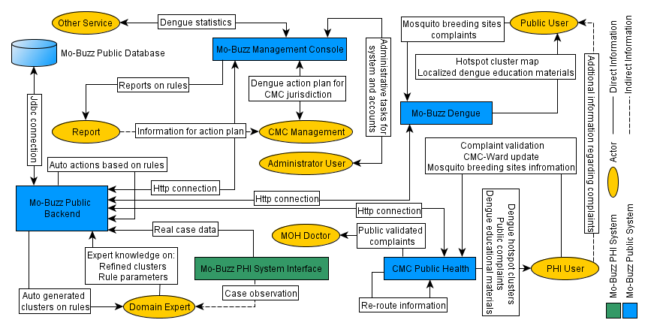

Figure 1: Overall architecture of Mo-Buzz Public System

# SOFTWARE OVERVIEW

# DESCRIPTION

Mo-buzz mobile clients are developed using android platform and development in java. The backend and the web-client are running on PHP, and hosted with apache. Json is used for communication whenever necessary. Most communication with mobile clients is done through RESTful, however for places where it needs backward compatibility with older mobile apps (versions which is on the android market) REST communication is used.

The system compatibility information as follows:

Version Misc

Android 4.0 or above Tested on 4.1.2 and 4.4

Apache 2.4.10

PHP 5.3

MySql 5.6

Note:

* Mo-Buzz Dengue is developed specially for mobile screens; however it can run on tablets as well. Smallest resolution support is 480x800 pixels.
* CMC Public Health is design for 7-inch tablet screens and optimum clarity is show on screens which have similar sizes (1024 x 600 pixels). I also can run on mobile screens as well.
* Mo-Buzz Management console is designed for desktops. It also can run on tablet screens. However, this may lead to difficulties in showing details under low resolutions/browser options of tablet screens. We recommend to use Google-Chrome browser for this website.

# SOFTWARE ARCHITECTURE

* + 1. ‘Mo-Buzz Dengue’ architecture

The diagram shown below explains main information flows for public involvement in Mo-Buzz system. The flowchart gives the paths of information which runs the logics in Mo-Buzz Dengue client and its communication with the backend server.

(Please refer the “*.png” or “*.graphml” files for the high resolution diagram)

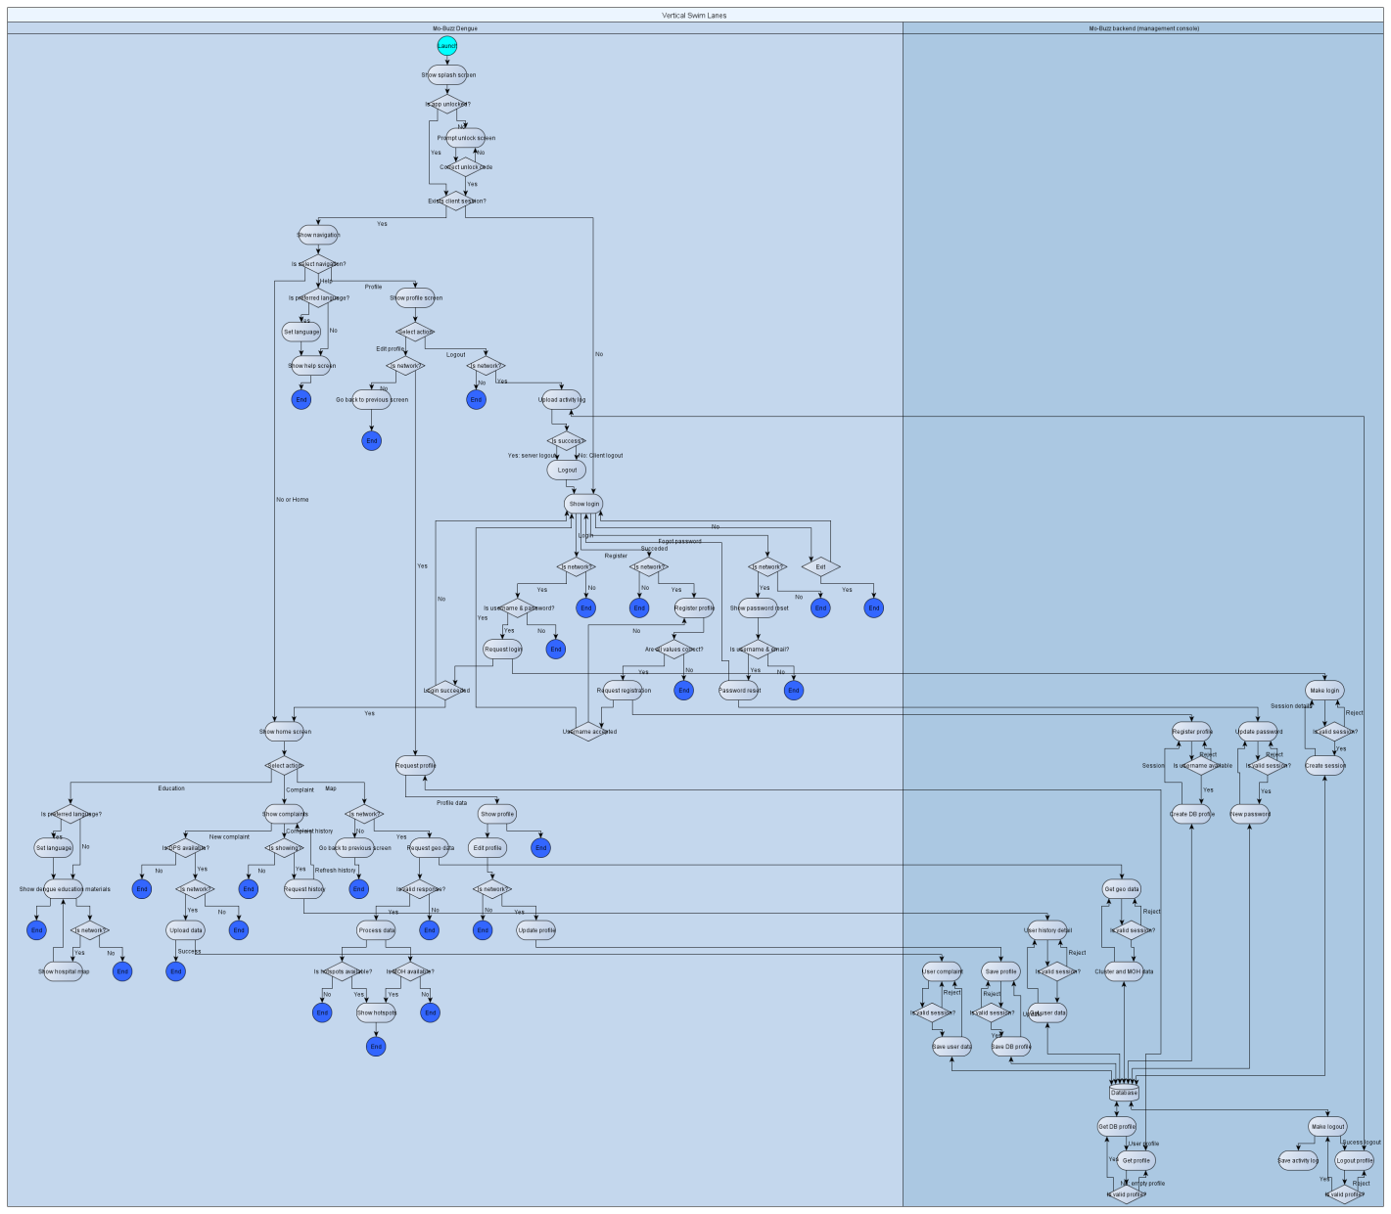

Figure 2: Flow chart for Mo-Buzz Dengue

The package and class diagrams for the android logics are shown in below. However this may not show all UI behaviors, since some of them are define in the configuration files.

(Please refer the “*.png” or “*.ucls” files for the high resolution diagrams)

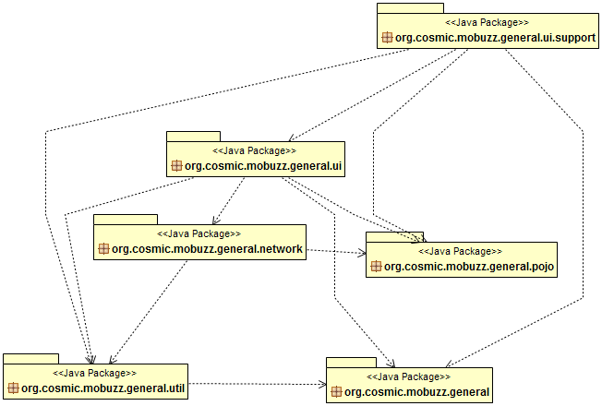

Figure 3: Package diagram for Mo-Buzz Dengue

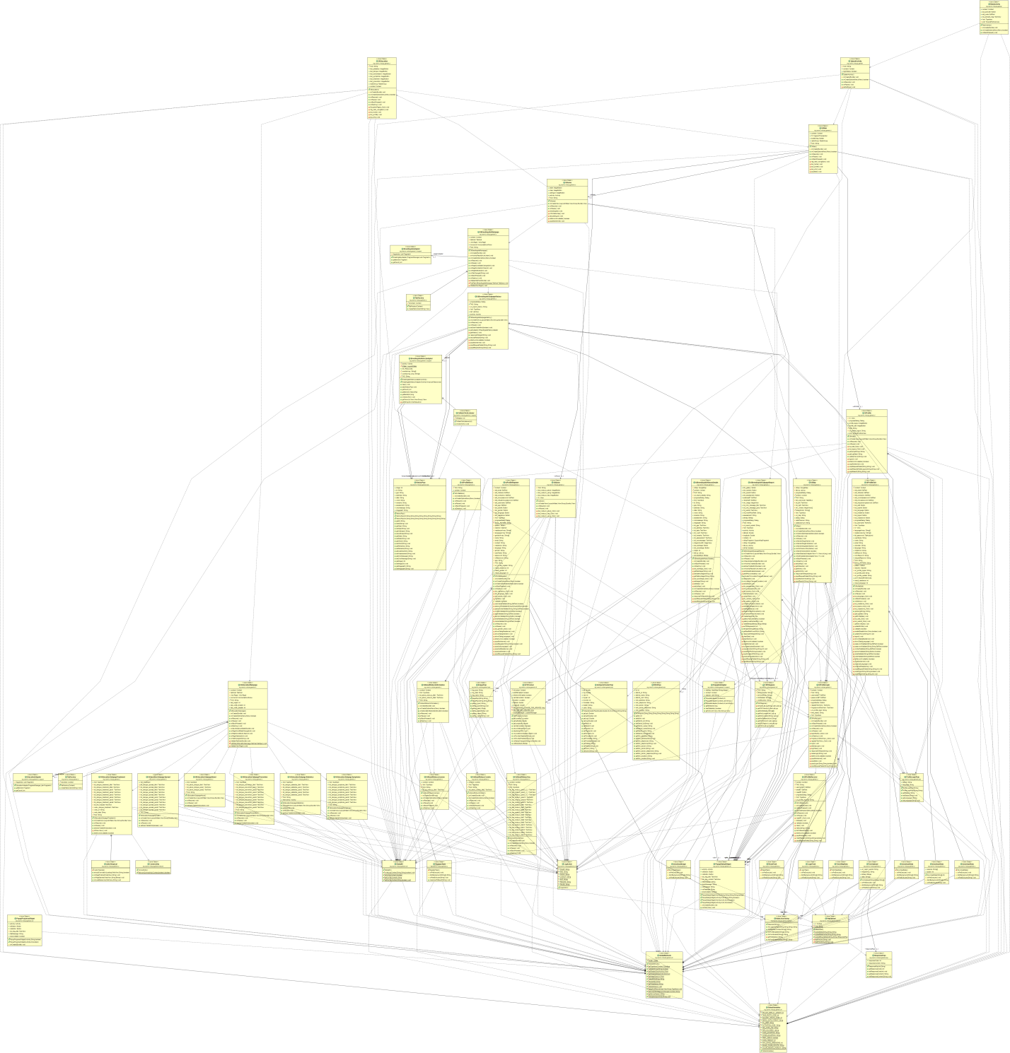

Figure 4: Class diagram for Mo-Buzz Dengue

* + 1. ‘CMC Public Health’ architecture

The diagram below explains the main information flows for validating the public content in Mo-Buzz system and enabling same facilities in Mo-Buzz Dengue app for PHIs. The flowchart gives the paths of information which runs the logics in CMC Public Health client and its communication with the backend server.

(Please refer the “*.png” or “*.graphml” files for the high resolution diagram)

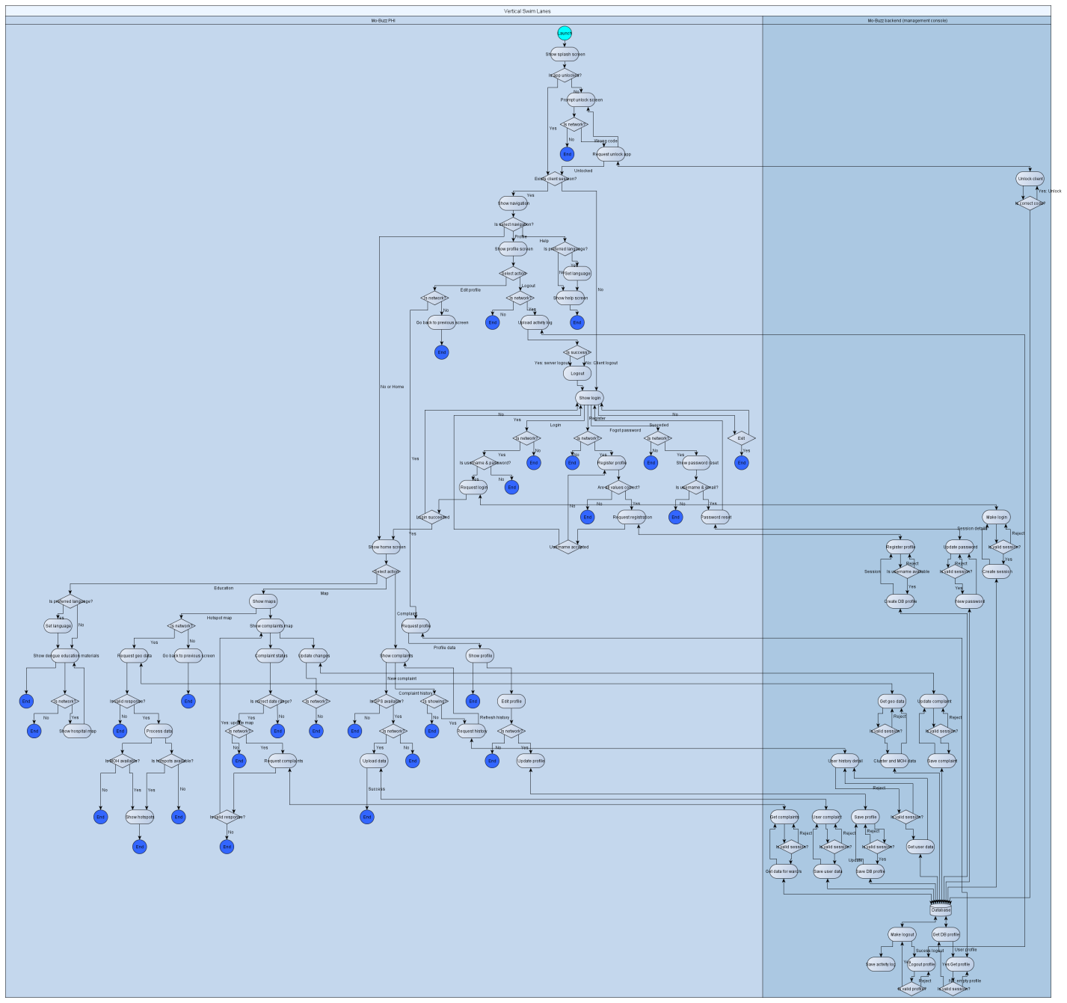

Figure 5: Flow chart for CMC Public Health

The package and class diagrams for the android logics are shown in below. However this may not show all UI behaviors, since some of them are define in the configuration files.

(Please refer the “*.png” or “*.ucls” files for the high resolution diagrams)

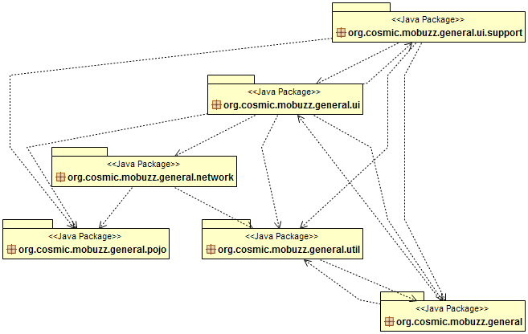

Figure 6: Package diagram for CMC Public Health

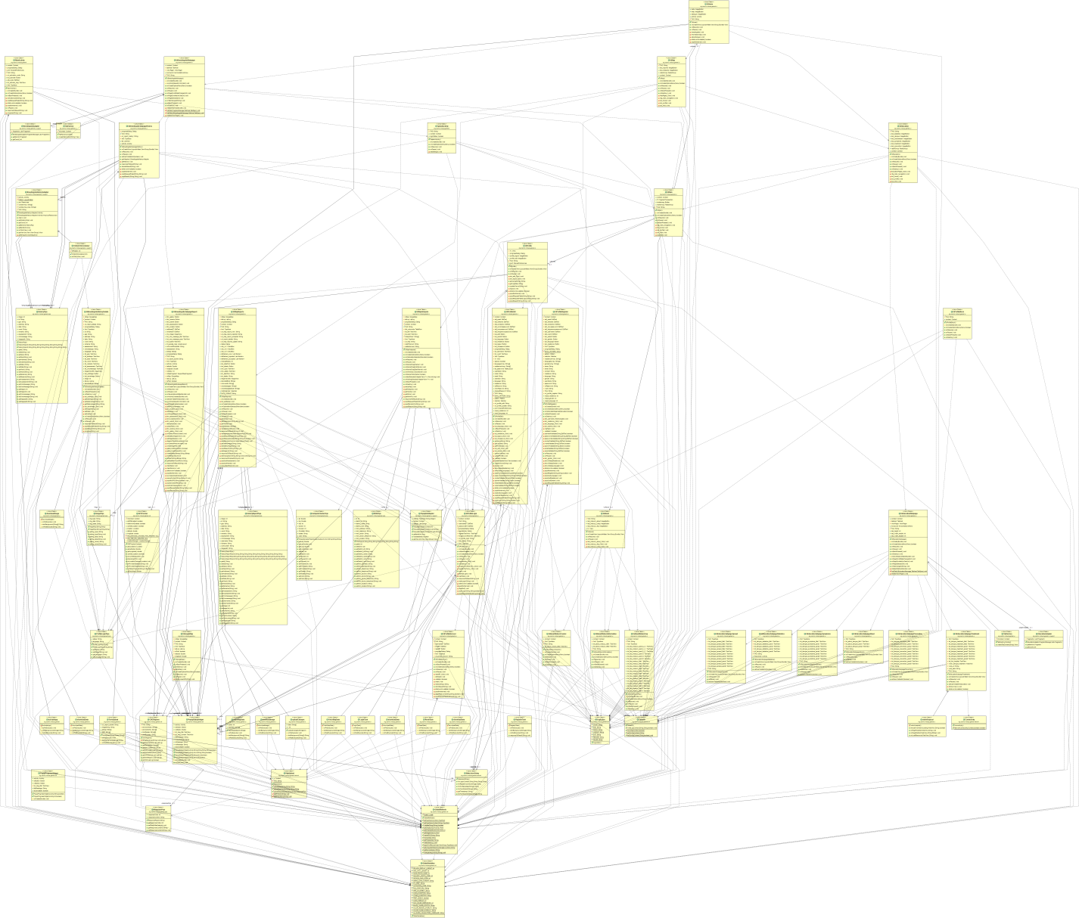

Figure 7: Class diagram for CMC Public Health

# USER INTERFACES

This section explains the interaction of Mo-Buzz system with its users. Above explained functionalities are exposed through the user interfaces (UIs); hence exposed functionalities, application behavior and its limitation are listed according to its navigation in the application.

# Mo-Buzz Dengue

* + - 1. Navigation

1. Log-in
   1. Register
   2. Forgot password
2. Main page
   1. Home
      1. Breeding site Complaint
         1. Form
         2. Complaint history
            1. Complaint history detail
      2. Map
      3. About Dengue
         1. About dengue detail
            1. Statistics
            2. What is dengue
            3. Transmission
            4. Symptoms
            5. Treatment
            6. Prevention
   2. Profile
      1. Log-out
      2. Edit
   3. Help
      1. About COSMIC
      2. FAQ
      3. About Mo-Buzz
         1. UI components

|  |  |  |
| --- | --- | --- |
| **Component** | **Objectives** | **Limitations/Restrictions** |
| 1. Log-in | 1. Log-in using correct username and password | 1. Username should contain only: abcdefghijklmnopqrstuvwxyz0123456789.-_ |
| 1.1 Register | 1. Fill personal details 2. select residence, language and gender 3. More information regarding the application can get from the menu | 1. Username should contain only: abcdefghijklmnopqrstuvwxyz0123456789.-_ 2. Username should be unique among users 3. Contact number should be 10 digits 4. Username and password should be at least 6 characters in length |
| * 1. Forgot password | 1. Password is reset to “username” if user provided correct username, and email which used in the registration |  |
| 2.1.1.1. Form | 1. Show the current GPS location to the user 2. Add an image through camera or photo-gallery 3. Add information about the breeding site to the report 4. Submit the report with above information | 1. GPS-coordinates are mandatory 2. Warn if the GPS-coordinates are outside CMC region 3. An image or Description is mandatory |
| 2.1.1.2. Complaint history | 1. Show list of submitted reports (in summary) | 1. If image is uploaded with the report, download icon is highlighted |
| 2.1.1.2.1. Reporting history detail | 1. Show the uploaded report in detail 2. If image was added to the report and not in the storage, thumbnail-image is downloaded 3. If image is already saved in the store, load the image from storage. 4. If thumbnail image is shown, full image download button is shown. 5. If image is downloaded from internet and is showing, image save button is shown. |  |
| 2.1.2. Map | 1. Show Google map with CMC-MOH regions 2. Show MOH details upon clicking a marker 3. Hotspots show with the respective date-range | 1. If the hotspots for current week is unavailable, nearest week hotspot map is shown |
| 2.1.3. About Dengue | 1. Respect detail section is shown upon clicking the category icon |  |
| 2.1.3.1. About dengue detail | 1. Details of the same section can see by moving the page up and down 2. Different sections can be selected by moving page left and right |  |
| 2.2.1. Log-out | 1. Logout the current user and redirect to the login page | 1. Internet connection is required for logout |
| 2.2.2. Edit | 1. Previously entered personal details can be changed 2. User password can be changed 3. User can sign out(log-out) and will redirect to the login page | 1. Current password is required for any change |
| 2.3.1. About COSMIC | 1. COSMIC information is shown |  |
| 2.3.2. FAQ | 1. FAQ about the application is shown |  |
| 2.3.3. About Mo-Buzz | 1. Details about Mo-Buzz is shown 2. Privacy policy is shown in menu |  |

# Mo-Buzz Dengue Management Console

3.3.2.1 Navigation

1. Dashboard
2. Complaints
   1. Edit
      1. Report detail
   2. Delete
3. PHI
   1. Change
      1. PHI detail
4. Map
5. Clusters
   1. Generate clusters
   2. Cluster data
6. Public Users
7. Search
   1. Edit
      1. Report derail
   2. Delete
8. Gallery
9. Downloads
10. MOH
    1. Edit
11. Administrator
12. New Admin (from Administrator only)
    * + 1. UI components

|  |  |  |
| --- | --- | --- |
| **Component** | **Objectives** | **Limitations/Restrictions** |
| 1. Dashboard | 1. Show current summary of statistics 2. Show current month’s ward-wise public reports (pending and attempted requests) 3. Show last month’s attempted reports in ward-wise 4. Show current year’s report statistics(pending and attempted requests) in month-wise |  |
| 2. Requests | 1. Show reports according to selected date-range and report-status 2. Reports are grouped by ward | 1. Both Public and PHI reports are shown |
| 2.1. Edit | 1. Show report in detail |  |
| 2.1.1. Report derail | 1. Show user’s details 2. Show report’s details 3. Can change the CMC message to for the report 4. Can change the CMC ward of the report | 1. Images are optional, and may not be in equal dimensions |
| 2.2. Delete | 1. Stop showing report in all systems |  |
| 3. PHI | 1. Show details of PHIs |  |
| 3.1. Change | 1. Show PHI in detail |  |
| 3.1.1 PHI detail | 1. Show PHI details 2. Can change the PHI ward | 1. “no wards”/* – PHI with no CMC ward allocation 2. 0 – repots outside CMC region |
| 4. Map | 1. Show reports according to selected date-range and report-status 2. Show report in details upon clicking a marker |  |
| 5.1. Generate clusters | 1. Show markers(actual data points) used to generate clusters 2. Create clusters according to predefine parameters 3. Clusters can be show/Hide based on the checkbox status 4. Cluster centre and radius can be adjust | 1. Year should be 2012 when loading data since, 2012 data-set is used for the testing. |
| 5.2. Cluster data | 1. Data records insert, delete or update that used for cluster generation |  |
| 6. Public Users | 1. List public users registered in the system 2. Can block or Unblock public users |  |
| 7. Search | 1. Show reports according to selected date-range, username and report-status 2. Reports are grouped by username |  |
| 7.1 Edit | 1. Show report in detail |  |
| 7.1.1. Report derail | As same as: 2.1.1.Report derail |  |
| 7.2 Delete | 1. Stop showing report in all systems |  |
| 8. Gallery | 1. Show images according to selected date-range, and report-status |  |
| 9. Downloads | 1. Download user event-listing repots |  |
| 10. MOH | 1. Show MOH details 2. MOH derails can be updated |  |
| 11. Administrator | 1. List administrators registered in the system 2. Can block or Unblock public administrators 3. Administrator details can be updated |  |
| 12. New Admin Administrator | 1. Add a new administrator |  |

# CMC Public Health

* + - 1. Navigation

1. Log-in
   1. Register
   2. Forgot password
2. Main page
   1. Home
      1. Breeding site Complaint
         1. Form
         2. Complaint history
            1. Complaint history detail
      2. Map
         1. Hotspot map
         2. Reports map
      3. About Dengue
         1. About dengue detail
            1. Statistics
            2. What is dengue
            3. Transmission
            4. Symptoms
            5. Treatment
            6. Prevention
   2. Profile
      1. Log-out
      2. Edit
   3. Help
      1. About COSMIC
      2. FAQ
      3. About Mo-Buzz
         1. UI components

|  |  |  |
| --- | --- | --- |
| **Component** | **Objectives** | **Limitations/Restrictions** |
| 1. Log-in | 1. Log-in using correct username and password | 1. Username should contain only: PHIDMO/0123456789 2. PHI must have valid CMC-ward combination |
| 1.1 Register | 1. Fill personal details 2. select language 3. More information regarding the application can get from the menu | 1. Username should contain only: PHIDMO/0123456789 2. Username should be unique among users 3. Username must contain at least one “/” character 4. Contact number should be 10 digits 5. Ward numbers should separated by commas 6. Username and password should be at least 6 characters in length |
| * 1. Forgot password | 1. Password is reset to “username” if user provided correct username, and email which used in the registration |  |
| 2.1.1.1. Reporting form | 1. Show the current GPS location to the user 2. Add an image through camera or photo-gallery 3. Add information about the breeding site to the report 4. Submit the report with above information | 1. GPS-coordinates are mandatory 2. Warn if the GPS-coordinates are outside CMC region 3. An image or Description is mandatory |
| 2.1.1.2. Complaint history | 1. Show list of submitted reports (in summary) | 1. If image is uploaded with the report, download icon is highlighted |
| 2.1.1.2.1. Complaint history detail | 1. Show the uploaded report in detail 2. If image was added to the report, image is downloaded |  |
| 2.1.2.1. Hotspot map | 1. Show Google map with CMC-MOH regions 2. Show MOH details upon clicking a marker 3. Hotspots show with the respective date-range | 1. If the hotspots for current week is unavailable, nearest week hotspot map is shown |
| 2.1.2.2. Reports map | 1. Show reports according to selected date-range, and report-status 2. Show Report details upon clicking a marker 3. Can change the CMC message to for the report 4. Can change the CMC ward of the report | 1. Reports will load based on the PHI’s ward allocation 2. If image is uploaded with the report, download icon is highlighted |
| 2.1.3. About Dengue | 1. Respect detail section is shown upon clicking the category icon |  |
| 2.1.3.1. About dengue detail | 1. Details of the same section can see by moving the page up and down 2. Different sections can be selected by moving page left and right |  |
| 2.2.1. Log-out | 1. Logout the current user and redirect to the login page |  |
| 2.2.2. Edit | 1. Previously entered personal details can be changed 2. User password can be changed 3. User can sign out(log-out) and will redirect to the login page | 1. Current password is required for any change |
| 2.3.1. About COSMIC | 1. COSMIC information is shown |  |
| 2.3.2. FAQ | 1. FAQ about the application is shown |  |
| 2.3.3. About Mo-Buzz | 1. Details about Mo-Buzz is shown 2. Privacy policy is shown in menu |  |

# DATABASE

Following diagram illustrate the architecture of the database used in the Mo-Buzz Public system. Data validation and restriction is done in logistics (application layer) as well as in database layer. Data are stored in various formats; hence all the data are not stored in the database. Actual images and user-logs are stored separate directories under hosted directory.

Note:

Public images are stored in: [root-directory]\ public_images

User logs are stored in: [root-directory]\ user_logs

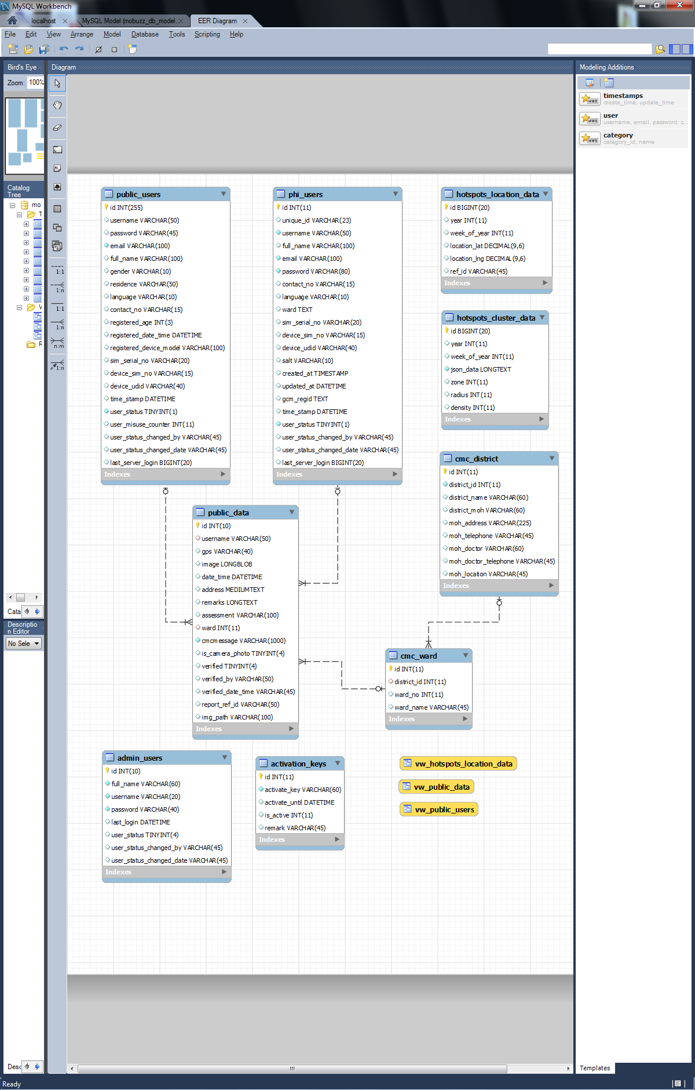

Figure 8: Database design of the system

# RELATED SOFTWARE

# DEPENDENCIES

Android clients

gson (Gson-2.2.2)

google-play-service_lib (Google maps)

Web Client/Backend

Google APIs : <https://www.google.com/jsapi>

<https://code.google.com/p/explorercanvas/>

Bootstrap: <http://getbootstrap.com/>

Jquery: <http://code.jquery.com/>

jQuery EasyUI : <http://www.jeasyui.com/>

# DEPLOYMENT OF THE SYSTEM

* 1. CODEBASE

Mo-Buzz codebase in SVN: https://cosmic-server/svn/mbuzz/trunk/Public System

* 1. DEPLOYMENT STEPS

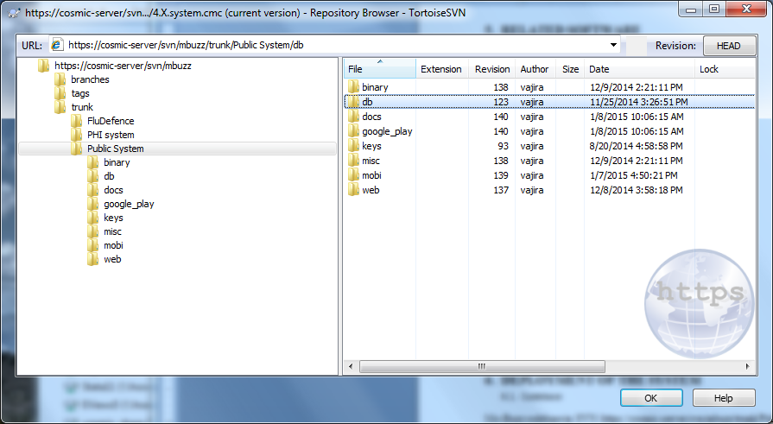

**Step1**

Download the SVN code.

**Step2**

Setup Database: Import the .sql file in “db” folder. This will create a database call “mobuzz_db”

**Step3**

Setup Backend and Web-client: Host the “mobuzz” directory in “web” folder, in your webserver.

Open the “constantes.php” file inside the “mobuzz” directory and update the following parameters according to your database and server details.

Parameters that need to be update:

HOST – hosting server name or IP

USER_NAME – DB connecting user

PASSWORD – DB connecting password

HOST_IP – IP of the hosting server

Note: “public_images” and “user_logs” directories should received write permissions from the *.php files (in Linux environments).

Start the server.

**Step4**

Import “google-play-services_lib”, “mobuzz.general_dev” and “mobuzz.general_phi” projects in “mobi” folder to ADT(Android Development Tools).

Add the libs/lib-project again to the project (if file paths are prompting with the error mark).

Note: You may have to update “google-play-services_lib” according to your android version.

Create a key for Google-services on android. Please follow link for detail: <https://developers.google.com/maps/documentation/android/start>

Update the “AndroidManifest.xml” (in both projects) with the new key.

Update the server information in the android clients (in both projects): [project] 🡪 res 🡪 values 🡪 strings_urls.xml

Change the server IP:PORT with the new values

<string name=*"url_server_port"*>http://202.129.235.206/mobuzz</string>

Clean and Rebuild the application.

Directly deploy or generate .apk(s) for the projects.

# APPENDIX

.PNG files – Open in image viewers

.UCLS files – Open in Eclipse IDE with

‘ObjectAid UML Explorer’ plugin: <http://www.objectaid.net/update>

.GRAPHML – yEd: <http://www.yworks.com/en/products/yfiles/yed/>

# 